MAR THOMA RESIDENTIAL SCHOOL-THIRUVALLA
CLASS: VII FIRST ASSESSMENT EXAMINATION 2020-21
BIOLOGY
MARKS: 20
TIME: 30 MIN
I NAME THE KIND OF TISSUE THAT [2]
- Covers the surface of the body and forms the lining of various body cavities and internal organs.
- Provides a passage for the downward and upward movement of food.
II WRITE TRUE OR FALSE [2]
- Cells are elongated and thick at the corners in parenchyma tissue.
- The cambium gives rise to new xylem ring every year.
III FILL IN THE BLANKS [2]
- The bone cells are embedded in a hard matrix of …………. and ………..salts.
- ……………tissue contains cells filled with fat globules.
- …………..is the structural and functional unit of life.
IV DEFINE THE FOLLOWING TERMS [2]
- Organ
- Tissues
V WRITE A SIGNIFICANT DIFFERENCE BETWEEN [2]
- Tendon and Ligament
- Xylem and Phloem
VI GIVEN BELOW IS A DIAGRAM OF A MUSCULAR TISSUE [4]
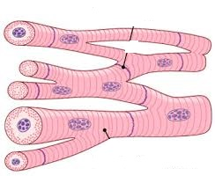

- Identify it.
- Give the exact location of it.
- Write any two features of this muscular tissue.
VII ANSWER THE FOLLOWING QUESTIONS [2x3]
- Write three features of meristematic tissues.
- Draw the diagram of a neuron and label any three parts.

